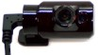
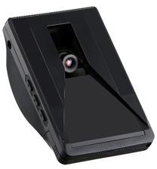
VS-800

DEVICE DESCRIPTION
The VS-800 is our Video Camera Solution that when partnered with the EZ- 750 becomes our fully integrated video solution. This combined solution comes with both a road facing and cabin facing cameras. Our system uses AI (artificial intelligence) to view & analyze what is happening on the road ahead. The VS-800 utilizes a combination of speed & TTT (time to target) plus its AI logic to determine what video is captured. For example, the AI camera picks up nearby vehicles, stop signs, traffic lights and can even read signs printed on the road (i.e., it will see the word STOP even if it’s painted on the road) to determine a video worthy event.

This product will support nearly all general business needs that are determined through a user assessment analysis, and or a desire to invest in a Video Solution. This combined solution also provides the visibility of vehicle PTO (power take off) activity such as identifying when a snowplow or truck
bed’s position is raised or lowered or when any secondary engine is engaged.
FLEET
The solution also provides audible beeps to “warn & coach” the driver when the AI determines there is danger ahead. It truly is a game changer in improving the safety of your employee and your vehicles, while providing the video clips when situations arise.

KEY FEATURES/BENEFITS
- Road Facing Camera - The road facing camera utilizes AI (artificial intelligence) to determine the following Video Alerts:
  - Crash & Roll Over
  - Harsh Events – Rapid Acceleration, harsh turns and hard Braking
  - Stop Sign & Stop Light Violations
  - Unsafe Driving: Tailgating, Collision Risk, Reckless Driving
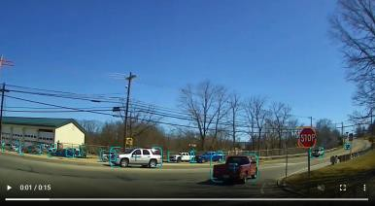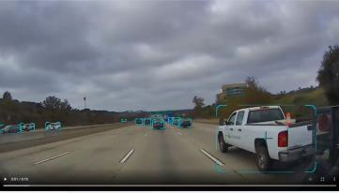
- Inward Facing (Driver Camera) – shows the driver’s behavior at
the time of the AI initiated events.
- Fully integrated into the SensLynx Fleet User Interface:
  - Alert History & Video Events Tab
  - Trip View
  - Reports
  - Mobile App
- Easy Installation – OBII & Jbus* connections allow for an easy installation.
*Jbus vehicles require the appropriate OBDII to Jbus cable

FLEET

DEVICE SPECIFICATIONS
Road Camera:
Field of view: 125° Resolution: HD (720P) Frame Rate: 25 FPS Image Sensor: Sony HDR Built In Speaker: Yes Built in Microphone: Yes
Cabin Facing Camera
Field of view: 125° Resolution: HD (720P) Frame Rate: 25 FPS
Image Sensor: Sony HDR 960 Events (4hrs)
Continuous Loop recording (16hrs) Still Cut Image (8 days)
Connectivity: 802.11 WiFi to EZ-750 Automatic Upload: Yes
On Demand Upload: Yes Mounting: Windshield Mount Power: 12VDC
Battery: Super Capacitor for PWR Shutdown
Size: 76.5mm x 121mm x 46.5mm Operating Temperature: -20°c to 70°C

VS-800

DEVICE SOFTWARE HIGHLIGHTS
- Web based; providing access to your ﬂeet information limited only by your access to the internet; including a mobile APP that will auto size for use with a smartphone or tablet.
- The VS-800’s AI generated videos are automatically uploaded to the servers.
- Easy to manage Video Alerts, simply check the Alert History Tab and ALL the alerts can be found there and sorted by vehicle.
- Realtime Alerts – All of the Alerts in our system, both Video and Vehicle based, can be sent automatically via Email or Text.
- Quick access to reports with our Get Report Now functionality.
- Auto Reports – allow you to automate the Video reports as well as all of our other Fleet Management type reports.
- Mobile App – ability to view video alerts on the Mobile App
- Road Facing & Cabin Facing Camera System
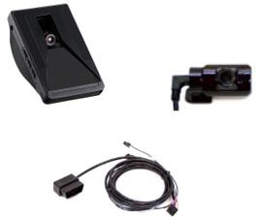
- Easy to connect - simple “Plug in Connections” to the EZ-750
- Jbus Cable’s available - 6 & 9 pin cables connect our OBDII connection to the larger Heavy Duty type vehicles.

OUR WARRANTY
We stand behind our equipment and software solution with our satisfaction guarantees
3-Year Device Warranty – If at any time during normal use your device stops working (excluding physical or water damage, or any change in cellular technology that renders the device obsolete) we will provide a replacement device at no charge. The commencement date is based upon the assignment of a billable rate plan to a device.
30-Day Money-Back – If at any time within 30 days after a device begins tracking you are not completely satisfied with your purchase or our soft- ware solution for any reason, we will give you a refund on the original purchase price of your device. (Not applicable with any leased/bundled program and does not include labor (if any)).

